Applying Ontology-Based Knowledge Representation in Warehouse Management Systems

Abstract—traditional database structures regularly struggle to address the semantic complexity and interoperability demanding situations inherent in warehouse operations. This paper investigates the software of ontology for a Warehouse management system (WMS), highlighting how ontological modeling enhances information illustration, reasoning, and choice-making. the usage of Protégé, a established ontology is advanced to version warehouse entities which includes products, garage locations, shipments, and suppliers, along side their interrelationships. The methodology follows a systematic process of specification, conceptualization, formalization, implementation, and assessment. The effects display ontology’s capability to improve actual-time tracking, lessen redundancy, and assist clever choice assist in warehouse operations. The examination concludes with a important mirrored image on ontology’s function in information management inside WMS and its broader significance in artificial Intelligence.
Keywords— ontology, warehouse management system, knowledge representation, Protégé, supply chain, reasoning, Artificial Intelligence

Introduction
In these day’s particularly aggressive commercial enterprise panorama, efficient warehouse management has become a cornerstone of supply chain success.
However, the developing complexity of warehouse operations starting from stock tracking and area utilization to shipment coordination and provider control has uncovered the restrictions of conventional database structures that generally manage facts with out capturing its semantic meaning [1]. Ontology, a center concept in artificial Intelligence (AI), provides a solution by presenting a based and semantically wealthy illustration of know-how inside a selected area [2]. In the context of a Warehouse Management system (WMS), ontology enables the definition of entities which includes products, classes, storage zones, suppliers, and transportation routes, while also modeling their interrelationships and constraints [3], [4]. This semantic approach not most effective facilitates interoperability and know-how sharing but also complements reasoning capabilities, allowing structures to infer new know-how and assist sensible choice-making [5].
This paper gives a investigative take a look at into the development and application of a ontology-primarily based Warehouse control system the usage of Protégé [6]. The take a look at outlines the methodology hired to assemble the ontology, analyzes its functionality to address actual-world warehouse control challenges, and critically discusses its ability blessings and obstacles [7]. by demonstrating how ontology can beautify know-how control in WMS, this research also contributes to the broader information of ontology’s role in artificial Intelligence packages [8], [9].

Case Study:Warehouse Management system

Problem Context
The main workflow of warehouse management system is simply managing the products across supply chain. Current warehouses cope with lots of merchandise, various providers, and complex logistics operations that must synchronize in actual time. Challenges including inaccurate stock records, inefficient area utilization, delayed order processing, and lack of interoperability across systems regularly avoid operational efficiency [7]. Conventional relational databases and control software normally shop records but fail to seize the semantic that means and interrelationships essential for superior reasoning and intelligent decision-making [1], [5].

Justification for Ontology Based Approch
Ontology provides a semantically wealthy framework to model warehouse entities and their relationships, allowing extra powerful knowledge representation and reasoning than conventional methods [2], [4]. By using defining classes which includes Product, StorageLocation, Order, Shipment, and Provider, along with their properties and constraints, an ontology-based WMS supports: semantic interoperability, facilitating data integration across heterogeneous systems [5]; reasoning capabilities, allowing automated inference, such as predicting inventory shortages or identifying most reliable storage zones [3]; reuse, making the model adaptable to one-of-a-kind warehouse contexts and scalable because the agency grows [6]; and advanced decision-making, presenting real-time insights for order prioritization, shipment scheduling, and resource allocation [1], [9].
For this reason, ontology offers a structured, reusable, and intelligent solution to overcome the complexity of modern warehouse management, surpassing the capabilities of conventional data management strategies [7].

Prior Knowledge Required for problem scenerio

Core Entities and Relationships
To efficiently model a Warehouse management system (WMS) the use of ontology, it's far essential to discover the essential components of warehouse operations, which can be commonly defined as classes, object properties, and data properties inside the ontology [2]. These key components serve as the foundational constructing blocks inside the semantic modeling of a warehouse. essential entities include Product (objects stored inside the warehouse), StorageLocation (physical areas where products are positioned), provider (resources offering stock), client (recipients of goods), Order (client-initiated requests), shipment (outbound flow of goods), and group of workers (personnel dealing with storage and distribution) [5].
These entities engage through specific object houses which includes hasLocation (Product → StorageLocation), suppliedBy (Product → supplier), placedBy (Order → client), fulfills (shipment → Order), and managedBy (StorageLocation → group of workers), thereby enriching the ontology with relational semantics [6]. Furthermore, warehouse operations adhere to numerous constraints and policies, including minimal and maximum inventory ranges, space allocation alternatives, prioritization of perishable goods, and function-specific staff duties. these policies can be encoded inside the ontology to allow for automated reasoning and validation [3], [7].
Technical concerns also play a critical function in constructing a strong WMS ontology. these consist of modeling the physical layout of the warehouse to guide spatial reasoning, analyzing present structures including database schemas or organization resource planning (ERP) structures for seamless integration, and aligning ontology design with business goals like inventory optimization, shortage prediction, and automatic reordering [1], [8], [9]. Ontologies allow information to be captured formally and reused throughout domains, helping interoperability and dynamic querying inside WMS systems [4]. In the long run, the semantic richness and flexibility furnished through ontology-based structures function them as powerful gear for designing intelligent and adaptable warehouse management architectures [2], [5].

Methodology
To expand the ontology for the Warehouse management system (WMS), we followed the well-set up 7-step technique proposed through Noy and McGuinness [3]. This approach is extensively recognized within the semantic web and ontology engineering network for its structured, iterative, and area-adaptable procedure of ontology construction, ensuring conceptual clarity, semantic accuracy, and interoperability qualities crucial for warehouse records systems that take care of diverse statistics types, real-time updates, and integration with outside systems [1], [5].
The technique become selected because it emphasizes innovative refinement, domain expert involvement, and reuse of existing ontologies, thereby reducing development time and enhancing quality [3], [7]. It was chosen for its clarity and structure, ability to handle complex domain-specific relationships, merchandising of reusability through popular vocabularies, and errors prevention through iterative evaluation [2], [5].
In the context of the WMS, the procedure began with defining the domain and scope, that specialize in warehouse operations and inventory management, mainly storage, retrieval, and movement of goods, without attempting to cover the entire supply chain [3].
Existing ontologies consisting of GoodRelations had been reviewed to reuse relevant ideas and ensure semantic compatibility [5], [8]. Key terms, including Warehouse, StorageUnit, InventoryItem, supplier, and shipment, together with important relationships like hasStorageUnit, containsProduct, and locatedIn, were enumerated [4], [6]. a top-down approach was used to outline a class hierarchy, in which broad classes like InventoryItem had been delicate into subclasses consisting of PerishableGoods and ElectronicItems to support hierarchical reasoning [3], [5]. Object and information properties had been precise, with domains, levels, and constraints consisting of cardinality to hold logical validity [6].
The ontology become then populated with sample times to simulate real warehouse statistics for checking out and reasoning purposes [4]. Once deployed, this ontology will serve as the semantic backbone of the WMS, supporting automatic reasoning to deduce indirect relationships, permitting sensible querying through SPARQL to address operational needs [3], [4], facilitating integration with IoT sensors, RFID systems, and cloud platforms [8], [10], and ensuring scalability to accommodate evolving warehouse tactics [5], [9]. Adopting the Noy and McGuinness technique ensured that the WMS ontology is logically constant, semantically wealthy, and operationally strong, presenting a solid basis for real-time, intelligent, and automatic warehouse management [3], [5], [8].

Implementation
Step 1: Determine the domain and Scope the selected domain for ontology development is Warehouse management systems. The scope encompasses key warehouse activities consisting of product managing, storage operations, order processing, cargo tracking, and supplier/customer interactions. The primary intention is to facilitate intelligent reasoning over stock status, product availability, and normal warehouse optimization. through semantically modeling those elements, the ontology helps automated selection-making in dynamic warehouse environments [1], [2].
Step 2: Remember Reuse before designing the ontology from scratch, current ontologies have been explored for capacity reuse. The GoodRelations ontology was examined for representing business product statistics, at the same time as sweet ontologies have been considered for spatial and location modeling [9]. But, due to the unique operational wishes and domain-particular intricacies of WMS, a custom ontology was deemed more appropriate. This method aligns with great practices in ontology improvement, which suggest reuse where possible, but additionally encourage tailored modeling for specialised domain names [7].
Step 3: Enumerate important phrases Key phrases relevant to the domain have been identified via evaluation of warehouse operations and stakeholder wishes. These phrases include product, order classes, storage, zones, shipment processes, employee roles, and supplier relationships [3].
Step 4: Define objects and Hierarchies The core ontology includes well-defined lessons established in hierarchies. for instance, the “Product” class is subclassed into “PerishableProduct” and “NonPerishableProduct” to differentiate among stock with and without expiry constraints. in addition, “Order” is subclassed into “InboundOrder” and “OutboundOrder” to symbolize different supply chain guidelines. additional primary lessons include “StorageZone,” “shipment,” “provider,” “client,” and “employee.” these taxonomies allow a semantically wealthy illustration of entities and their contextual relationships [6].
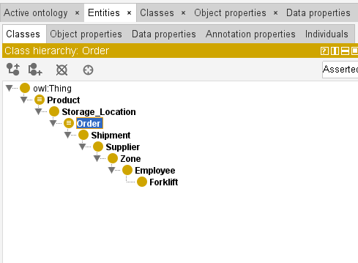
Figure 1: illustrates the basic classes

Step 5: Define Relationships among classes are modeled using object houses consisting of isStoredIn (Product → StorageZone), isShippedTo (Order → client), placedBy (Order → employee), and isSuppliedBy (Product → supplier). In parallel, statistics houses consisting of hasQuantity, hasWeight, hasStockLevel, hasOrderDate, and hasExpiryDate are defined to symbolize attributes of those lessons.
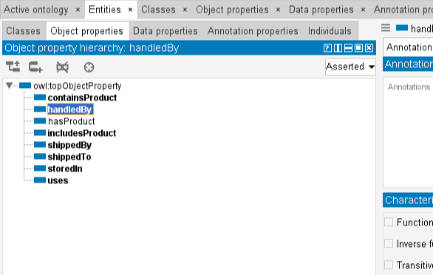
Figure 2: illustrates the object properties

Step 6: Outline sides (Constraints) Logical restrictions have been added using OWL constructs to enhance reasoning capabilities. for instance, cardinality constraints are used to put into effect policies consisting of a order being placed through precisely one employee. Datatype constraints make sure correct formats for dates and quantities. furthermore, conditional axioms have been applied, consisting of: "If a product has a expiry date, it ought to be a perishable product," improving inferencing accuracy and ontology validation [5], [6].
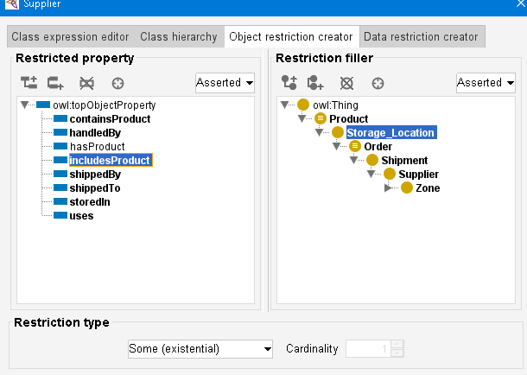
Figure 3: illustrates the OWL restrictions (e.g., cardinality, datatype constraints)

Step 7: Create instances (people) ultimately, individual instances representing actual-world statistics have been instantiated to test and validate the ontology. This includes instance merchandise, storage locations, and pattern orders, allowing dynamic reasoning over live warehouse scenarios. The instantiation step transforms the summary version into a usable information base that can power intelligent WMS applications [3], [4], [8]. through following this established technique, the advanced ontology not only models warehouse operations accurately but additionally allows semantic interoperability, automated reasoning, and scalable reuse across warehouse contexts [2], [5], [9].
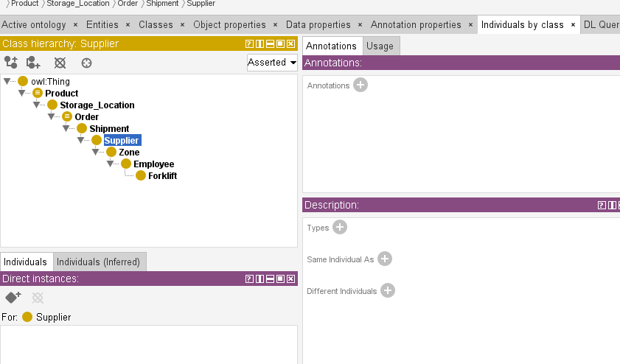
Figure 4: illustrates the individual by class hierarchy

Some Common Mistakes
In documenting the ontology improvement for a Warehouse Management System (WMS), appropriate scientific style and readability of language were maintained during the record. The following key practices had been followed to make certain grammatical accuracy and professional consistency: The phrase records is handled as a plural noun (e.g., “The inventory records had been retrieved from multiple sources”), this is particularly relevant while regarding object records, dealer logs, or shipment histories in warehouse databases [7]. Scientific constants and logos, inclusive of the permeability of vacuum (μ₀), are written using accurate subscript formatting [7]. Even though such constants may be less common in warehouse area ontologies, proper style is maintained in which units and constraints (e.g., storage temperature or weight) are discussed [6]. Punctuation is used appropriately with quotation marks. For example, “AvailableSlot” and “StorageZone” are used as ontology class names, with punctuation performing outside the quotes unless an entire phrase is being mentioned [1]. Inset charts (not “inserts”) are referenced appropriately while visualizing relationships inclusive of order success timelines or area utilization trends within the warehouse [3]. The term as a substitute is favored over alternately, particularly while outlining extraordinary workflow techniques for inventory management (e.g., “items can be as a substitute looked after with the aid of expiration date or transport priority”) [7]. The phrase essentially isn't always used to mean approximation or effectiveness, as such usage lacks precision. As a substitute, quantifiable descriptions are implemented (e.g., “The WMS helps approximately ninety-six percent actual-time accuracy in order tracking”) [5]. Name formatting follows IEEE style: for example, within the name “Ontology-based Modeling for Warehouse Management Systems Using Protégé,” the phrase “Using” is capitalized because it is able to be replaced with the phrase “that makes use of” [4]. Homophones are implemented efficiently: for example, warehouse weather control can affect (verb) product longevity, and the effect (noun) is a reduction in spoilage. Similarly, “discrete units” refers to individually counted inventory-holding units (SKUs), not “discreet” [9]. The difference between mean and infer is preserved. For example, the WMS might also mean an inventory-out situation based on trends, while the person infers essential reordering action [7]. Compound phrases with the prefix “non” are joined without hyphenation unless clarity needs it (e.g., nonperishable items, nonautomated storage) [2]. The Latin abbreviation et al. is formatted efficiently with no period after “et” (e.g., “as proposed with the aid of Smith et al.” in previous warehouse ontology studies) [8]. Abbreviations are used appropriately: i.e. (that is) and e.g. (for example) are followed by commas in accordance with IEEE standards [1].

Evaluation
in this phase, the advanced ontology for the Warehouse management system (WMS) is evaluated through the usage of inference reasoning and querying techniques to validate its structure and retrieve large information [3]. Ontology assessment is a vital step to ensure that the semantic model is logically sound, operationally accurate, and capable of assisting actual-international decision-making strategies in a warehouse setting. the primary stage of assessment specializes in the logical consistency of the ontology using preferred OWL reasoners including HermiT or Pellet, which can be incorporated with the Protégé ontology editor [1]. these reasoners mechanically classify the ontology through checking that all described classes, relationships, and property restrictions do not contradict each other.
They verify that all axioms, including disjoint classes or domain and range constraints, align with OWL semantics and do not result in unsatisfiable classes or faulty hierarchies. for instance, the reasoner will discover logical flaws like trying to area an inventory item in two disjoint sorts straight away or using wrong information types for particular properties. Moreover, reasoning allows the ontology to deduce new information through deriving relationships that are not explicitly said however logically follow from the present structure [3].
For instance, if a Product is connected to an StorageUnit, and the StorageUnit is connected to an Warehouse, then the reasoner can infer that the product is in a roundabout way placed in that warehouse, even though that courting changed into no longer explicitly modeled. This type of inference supports transitive property chaining, allowing more expressive and intelligent information illustration. Furthermore, taxonomy constructing is delicate via the right use of subclass hierarchies. categories including PerishableGoods and ElectronicItems are semantically modeled as subclasses of InventoryItem, allowing hierarchical category and contextual grouping [2], [5].
This hierarchical structure allows the WMS to apply guidelines and operations to entire categories with out manually specifying each character instance, enhancing automation and flexibility. After verifying logical soundness via reasoning, the following level of assessment involves SPARQL querying, which exams whether or not the ontology can support domain-particular information retrieval in real operational scenarios [4].
SPARQL, the query language for RDF-based ontologies, lets in users to retrieve exact and precise records from the semantic model. via a sequence of competency questions, the device’s responsiveness to real-world queries is assessed. Examples consist of: "What products are currently stored in a particular warehouse?", "Which storage devices contain perishable items?", and "what is the total count of inventory items in line with warehouse?" Such queries compare the ontology’s ability to support warehouse activities including inventory audits, logistics planning, and inventory rotation [6].
This level also confirms that the item and information properties—including hasStorageUnit, containsProduct, locatedIn, hasQuantity, and others—are properly defined, correctly related to applicable lessons, and yield accurate results when queried [3]. The querying phase further validates whether or not the relationships encoded within the ontology are bidirectional where needed, and whether or not restrictions (e.g., cardinality constraints) on properties are enforced correctly. for instance, querying for warehouses that keep more than a certain quantity of perishable items guarantees that the system handles numeric filters and class constraints correctly.
Moreover, queries can simulate dynamic use instances including tracking inventory turnover or identifying inventory imbalances, ensuring that the ontology is strong and able to coping with both current and future warehouse demands. collectively, reasoning and querying not only verify the structural and logical integrity of the ontology but also exhibit its practical application in helping intelligent warehouse operations. These techniques ensure that the ontology aligns with domain necessities, allows information interoperability, and can evolve with future system needs.

Conclusions
The Warehouse Management System (WMS) designed and implemented in this report presents a comprehensive and dependent method to handling warehouse information via ontology-based modeling. The system not best complements the performance of warehouse operations however additionally guarantees semantic consistency, ease of information integration, and wise reasoning.
The use of tools like Protégé, the ontology virtually defined classes which includes Warehouse, StorageUnit, InventoryItem, and their properties, permitting an system-comprehensible format for warehouse-associated facts [5]. The integration of reasoning competencies allowed for automatic inference of know-how, thereby revealing hidden relationships and validating the ontology's logical structure [3], [6]. Moreover, SPARQL queries confirmed how customers can extract meaningful insights from the ontology, assisting actual-time selection-making and efficient inventory tracking [4].
Through preserving compliance with W3C standards and leveraging semantic internet technology, the system helps scalability and future integration with IoT and cloud-based warehouse solutions [10]. In conclusion, this ontology-pushed Warehouse control gadget provides an strong technological foundation for wise, scalable, and automatic warehouse operations. It is able to function an important factor in modern supply chain ecosystems, contributing to improved productiveness, actual-time visibility, and clever resource utilization [8].

Appendix
Code

References
- [1] T. R. Gruber, “A translation approach to portable ontology specifications,” Knowledge Acquisition, vol. 5, no. 2, pp. 199–220, 1993, doi: 10.1006/knac.1993.1008.
- [2] D. Fensel, Ontologies: A Silver Bullet for Knowledge Management and Electronic Commerce, Springer-Verlag, 2001.
- [3] N. F. Noy and D. L. McGuinness, “Ontology Development 101: A Guide to Creating Your First Ontology,” Stanford University, Technical Report KSL-01-05, 2001. [Online]. Available: https://protege.stanford.edu/publications/ontology_development/ontology101.pdf
- [4] M. Horridge, S. Bechhofer, and N. Drummond, “A practical guide to building OWL ontologies using Protégé 4 and CO-ODE tools,” University of Manchester, 2009. [Online]. Available: http://owl.cs.manchester.ac.uk/tutorials/protegeowltutorial/
- [5] G. Antoniou and F. van Harmelen, A Semantic Web Primer, 2nd ed., MIT Press, 2008.
- [6] W3C OWL Working Group, “OWL 2 Web Ontology Language Document Overview (Second Edition),” W3C Recommendation, Dec. 2012. [Online]. Available: https://www.w3.org/TR/owl2-overview/
- [7] M. Uschold and M. Gruninger, “Ontologies: Principles, methods and applications,” The Knowledge Engineering Review, vol. 11, no. 2, pp. 93–136, 1996, doi: 10.1017/S0269888900007797.
- [8] T. Berners-Lee, J. Hendler, and O. Lassila, “The Semantic Web,” Scientific American, vol. 284, no. 5, pp. 34–43, 2001. [Online]. Available: https://www.scientificamerican.com/article/the-semantic-web/
- [9] M. Hepp, “Ontologies: State of the Art, Business Potential, and Grand Challenges,” Ontology Management, pp. 3–22, 2008, doi: 10.1007/978-0-387-69900-4_1.

IEEE conference templates contain guidance text for composing and formatting conference papers. Please ensure that all template text is removed from your conference paper prior to submission to the conference. Failure to remove template text from your paper may result in your paper not being published.

